**Continue Statement**

Continue statement is a keyword used to ***skips*** the statements under it, and ***transfers*** the control to the condition part of the loop in the context of while and do while loops statement where as in the context of for loop, control transferred to increment / decrement part.

Continue statement is used only inside loops.

Syntax of break keyword is: continue;

If the loop you want to continue has a label then break syntax will be: continue loop-label;

**Example1:**

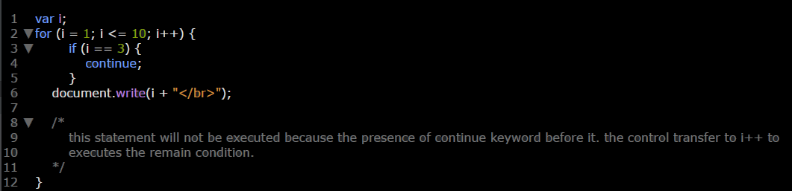

**Example2:**

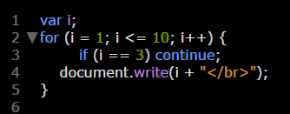

**Note:** in case of several loops if you continue the father loop (oldest loop) the newest loops inside it will also continue but the opposite isn’t true.

**Example 3:** in this example we continue Father Loop so child loops will be continuing also.

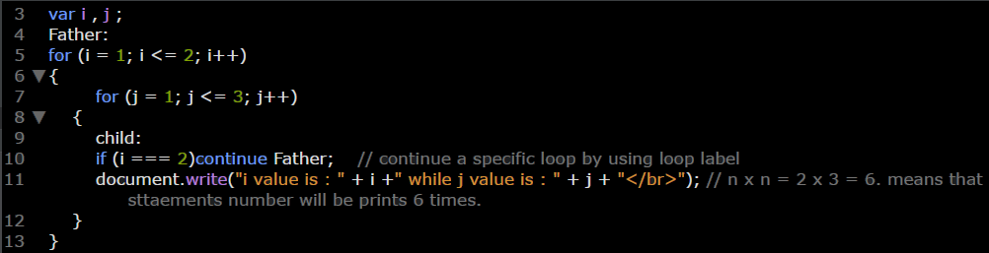

**Example 4:** in this example we continue child Loop so Father Loop will not be continue.

